Commercial Taxes Department – Leave Management System
URL: https://ctlms.cgg.gov.in
UserName: PAO / DTA Code; Initial Password: Registered Phone Number
Login Page
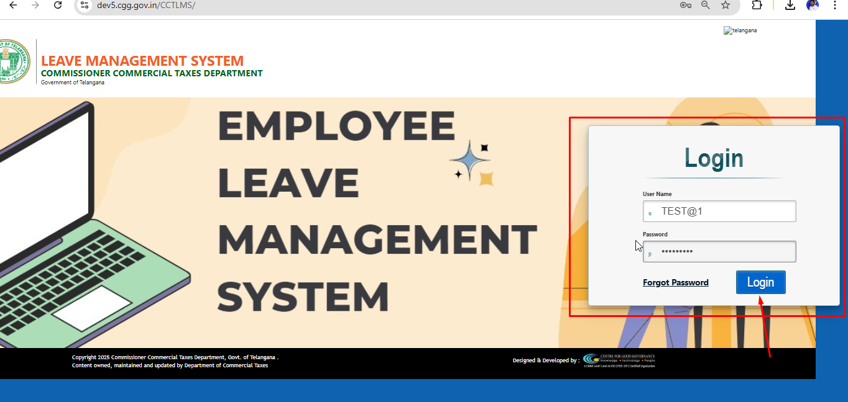
Apply Leave: TO apply leave select Services > Apply Leave
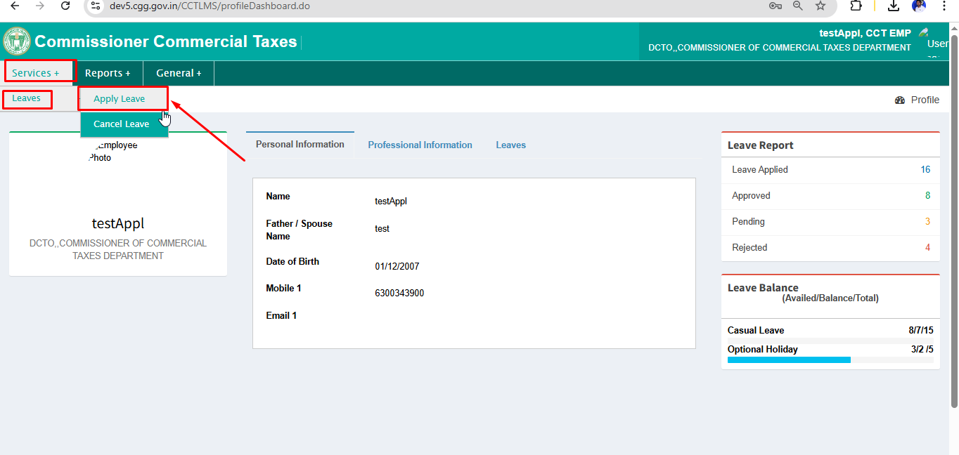

Apply Leave Screen: Enter the details in the below screen to apply leave
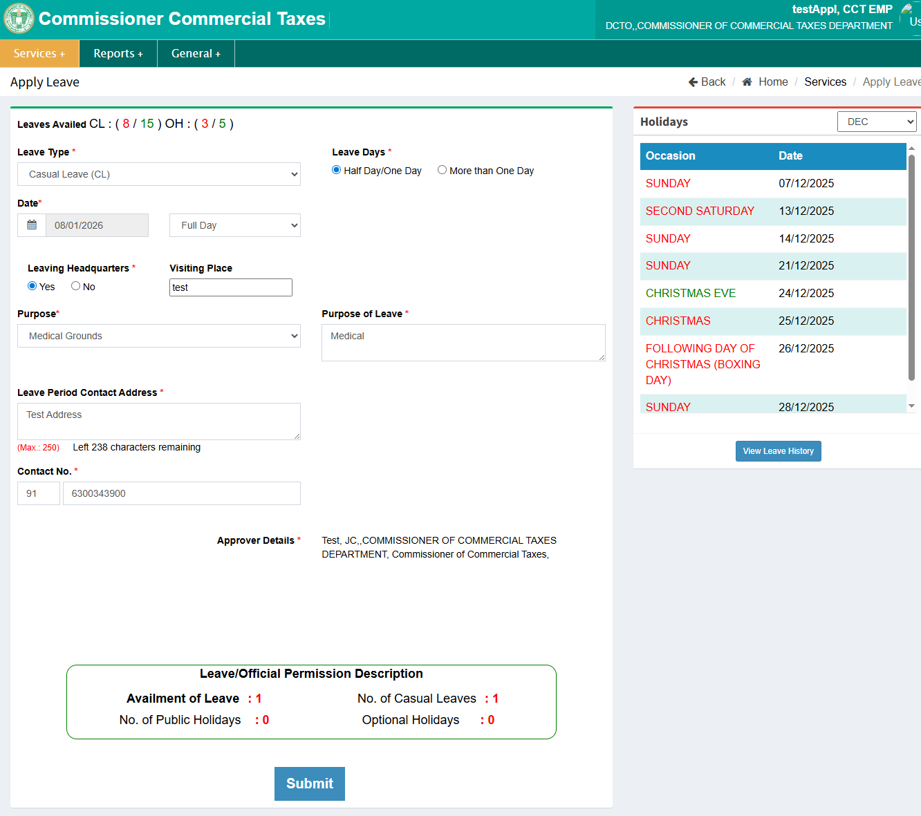
Click Submit to verify and submit the Leave Application. Below alert screen will appear.
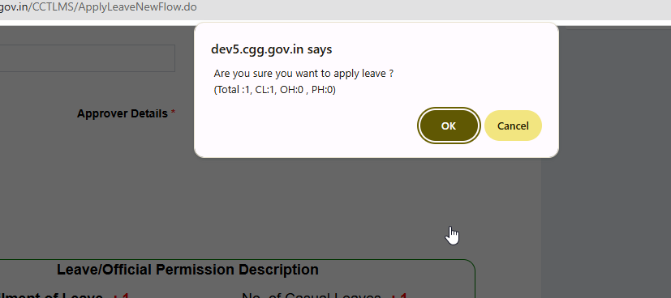

Leave Applied Successfully message will appear as shown below.
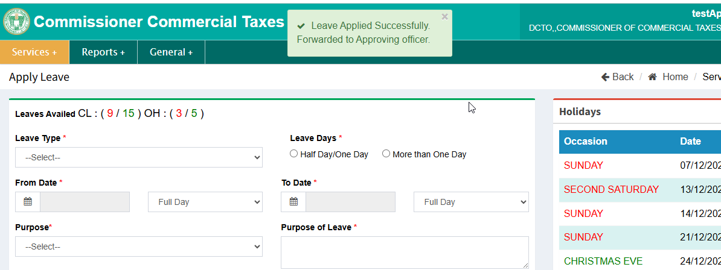

To Approve Leave: To Approve Leave select Services > Approve Leave
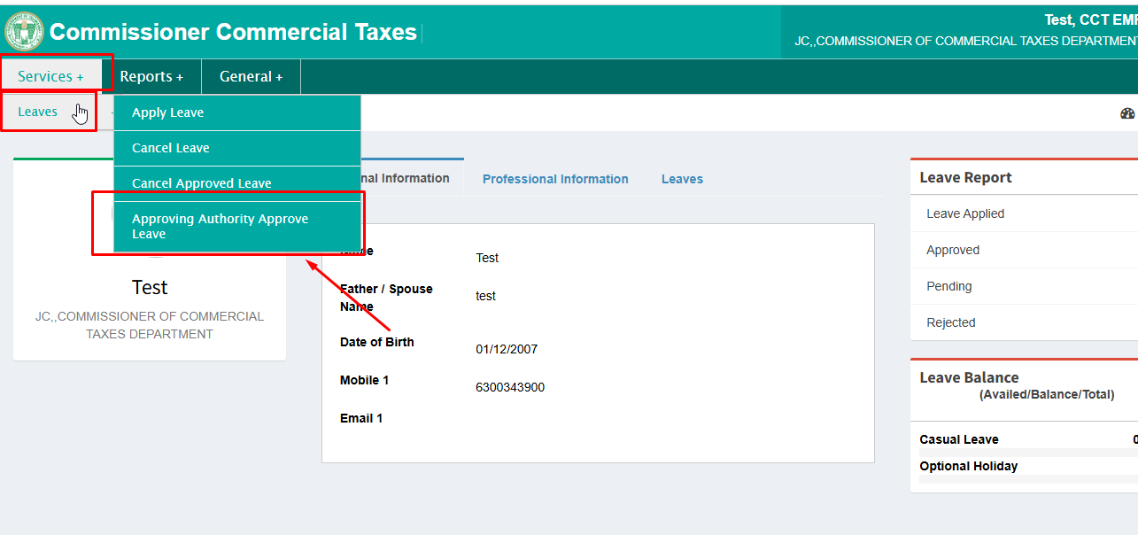

List of applications for leaves will be displayed. Approve or Reject the leaves as shown below.
